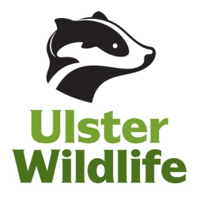
Ulster Wildlife Placement Opportunity 2024

Role Title: Youth and Community Work Student Placement

Responsible to: Community Engagement Manager – Alexey Janes.
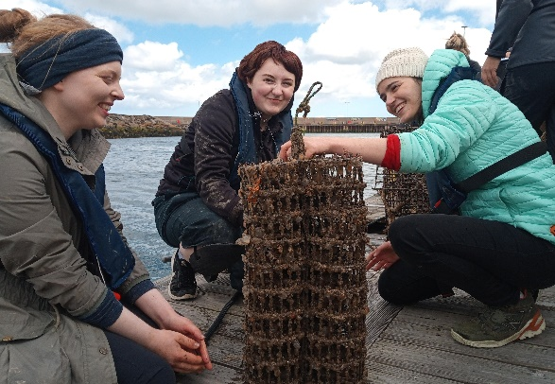
Role duration: One 30 hour a week 10 week placement.

Purpose of role:
The role of the placement student will be to assist in the delivery of youth and community work activities working alongside Ulster Wildlife project officers.

Main responsibilities:
- Assist in delivery of Wild Youth activity sessions alongside Wild Youth Outreach officer and others in and around the Belfast Hills/local green spaces.
- Assist with delivery of monthly Saturday Youth Volunteering group at Bog Meadows
- Assist with organising and delivering Youth Forum events and meetings.
- Assist with other Youth and Community or Nature Reserves work as instructed.
- Assist with preparation for 5 day Binevenagh Youth Residential (August 2024) at Magilligan Field Centre.

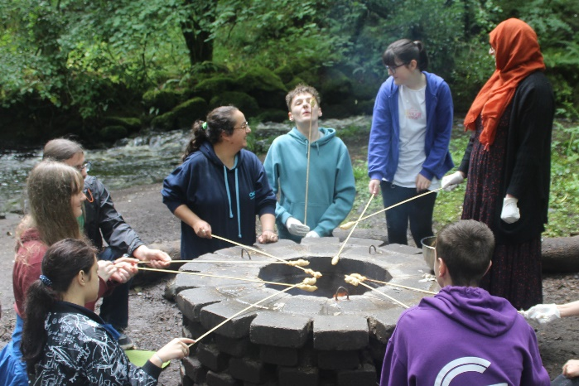
Skills required:
- Undertaking a Youth and Community Work degree or similar.
- Experience of youth and community work.
- Experience supervising activities with young people
- Excellent written and oral communication skills.
- IT skills – competent in MS Office; particularly Word and Excel.
- Excellent team worker.
- Motivated and able to work without supervision, well organised.
- Passionate about nature conservation.
- Willingness to learn.
- Able to work flexibly – i.e. evenings and weekends as well as during the week.
- Use of a car/driving licence.

Desirable skills:
- Knowledge and experience of nature based wellbeing work with young people.
- Knowledge of wildlife conservation in Northern Ireland.

Access NI Check: An Access NI check will be required prior to commencement of placement activity.

Placement location: Ulster Wildlife Offices, McClelland House, 10 Heron Road, Belfast, BT3 9LE

Training and travel expenses to Ulster Wildlife Offices will be provided with a daily mileage cap of 30 miles round trip @ 45p per mile.

Please send a CV and cover letter to volunteering@ulsterwildlife.org by 12 noon on
Wednesday 31st January 2024.

